**DB - Assignment # 2**

**Submission deadline Tuesday October 18, 2022 @ 11:55 PM**

**Submit on Google Classroom. No email submissions accepted. No deadline extensions.**

***Question # 1:***

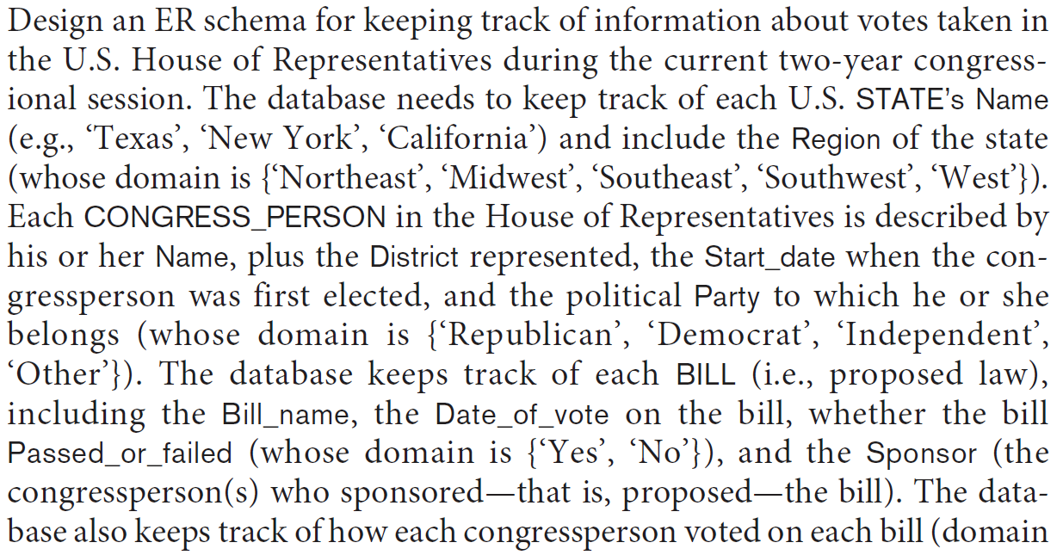

Additional information:

- There are 435 congresspersons in the U.S. House of Representatives.

- States have between one (AK, DE, MT, ND, SD, VT, and WY) and 52 (CA) representatives.

***Question # 2***

A database is being constructed to keep track of the teams and games of a sports league. A team has a number of players, not all of whom participate in each game.

It is desired to keep track of the players participating in each game for each team, the positions they played in that game, and the result of the game. Try to design an ER schema diagram for this application, stating any assumptions you make. Choose your favorite sport (soccer, football, baseball ...).

***Question # 3:***

